**Managing Data and Working with Volumes**

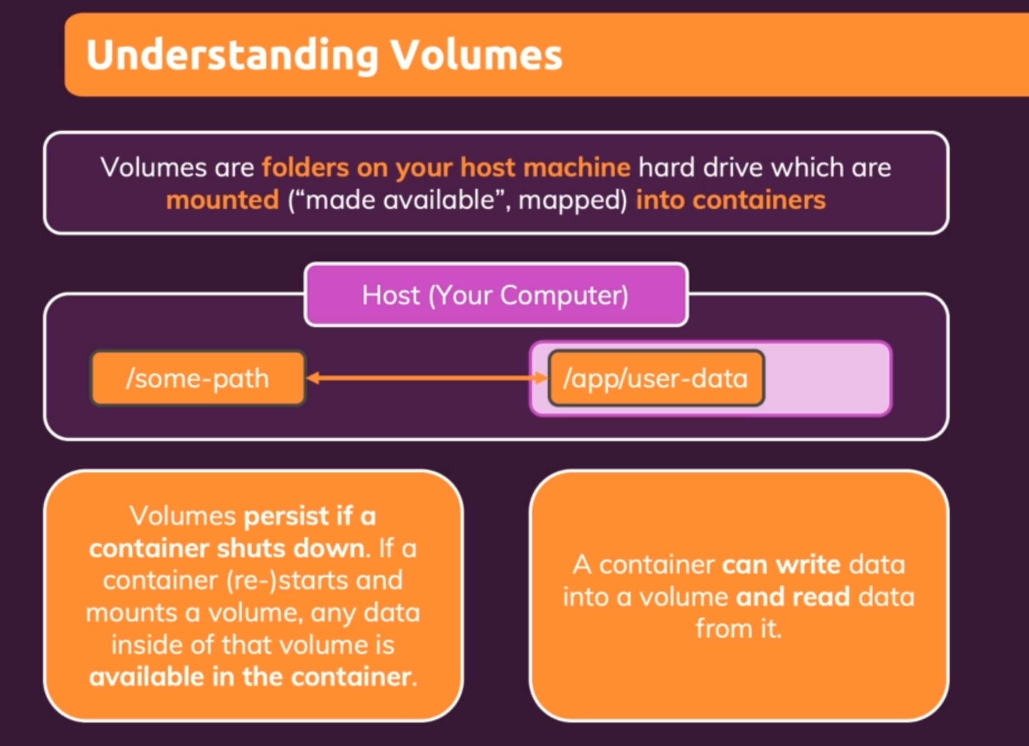



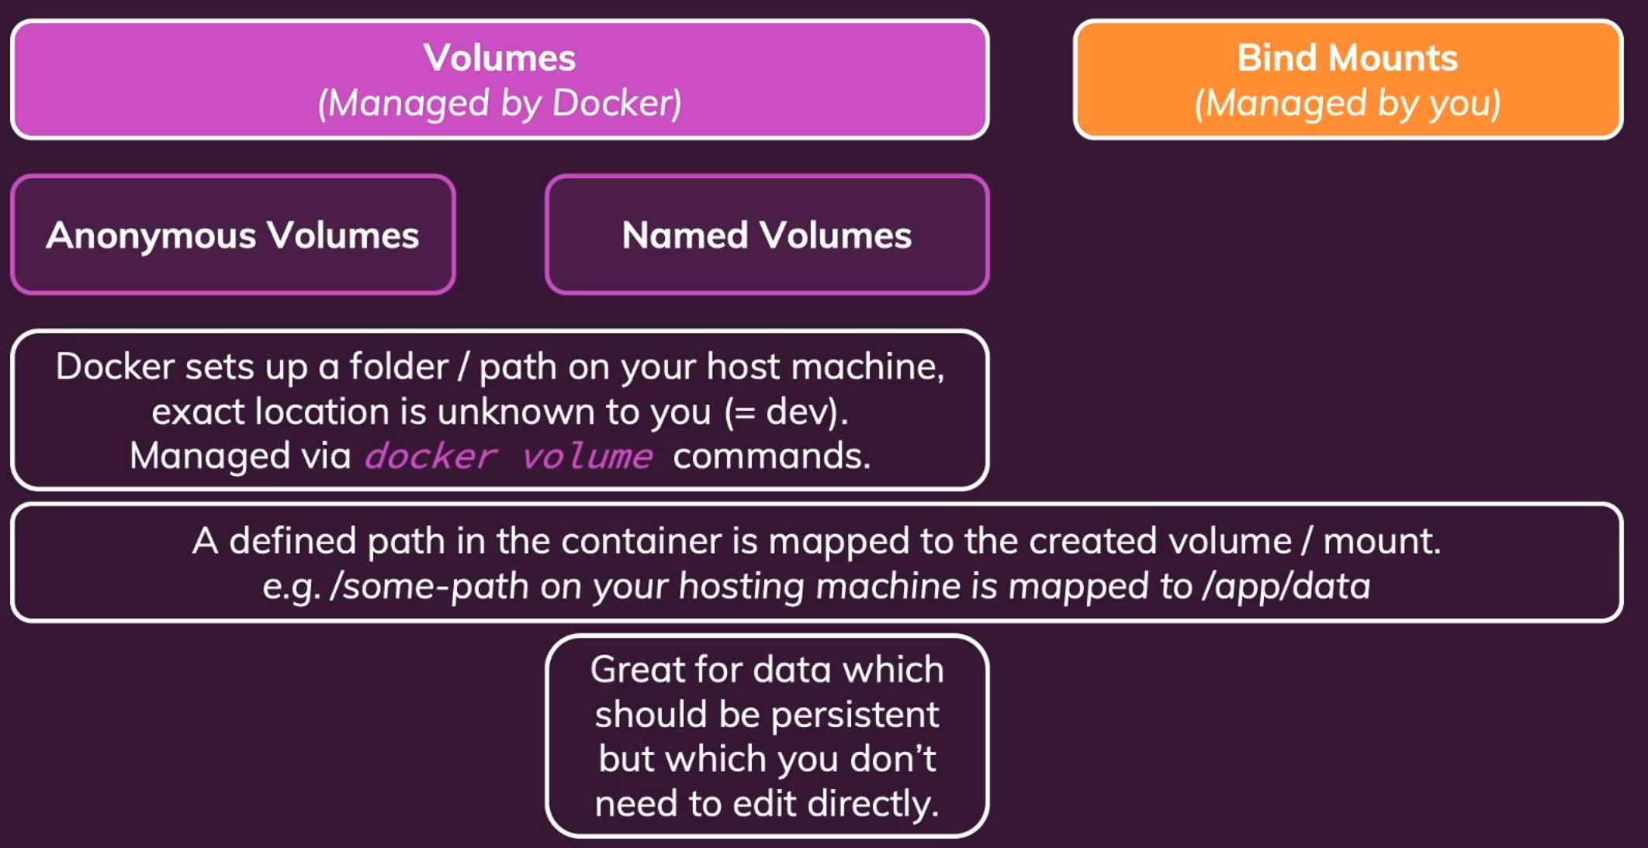

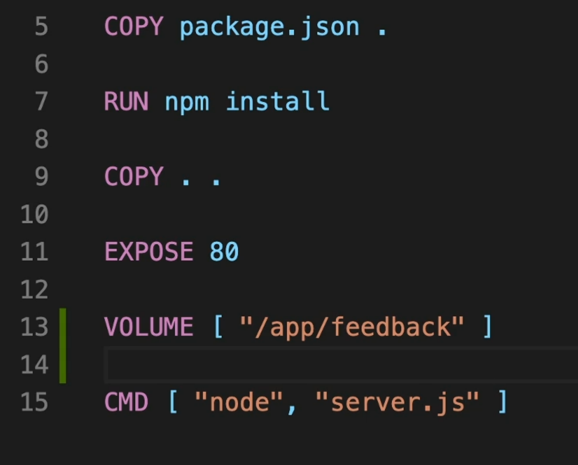

List all the volumes that docker is currently managing

Creating Anonymous Volume



Automatically generated name for anonymous volumes

Note: If we will stop our running container, the anonymous volume will be gone as we have run the docker command with “-rm”, so the container will be deleted and the volume will be gone.

**Named Volume:** To create a named volume we do not need to write instruction in the Dockerfile. We will run the command as below:



“**-v**” to create volume and *<Volume_Name>****:****<Path_to_the_folder_within_container>*

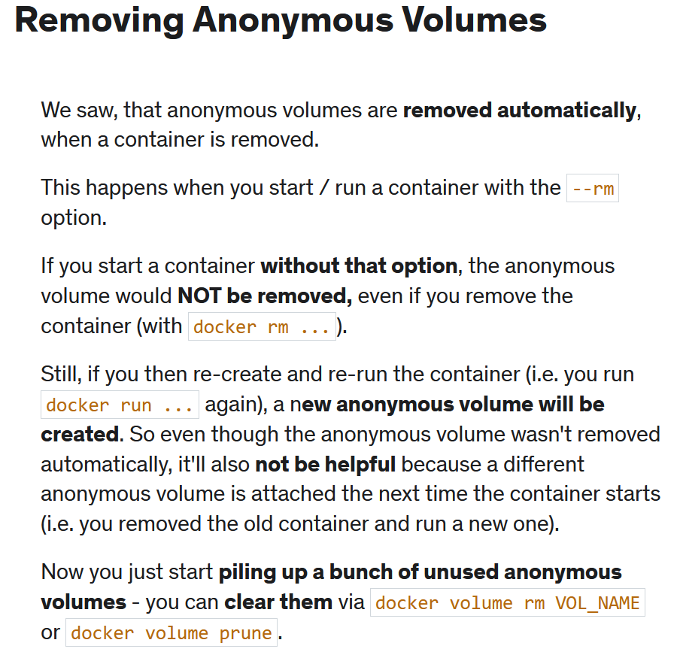

Bind Volumes:

A Bind Mount is **a storage area (file/directory) on your local machine available inside your container**. So any changes you make to this storage space (file/directory) from the outside container will be reflected inside the docker container and vice-versa.

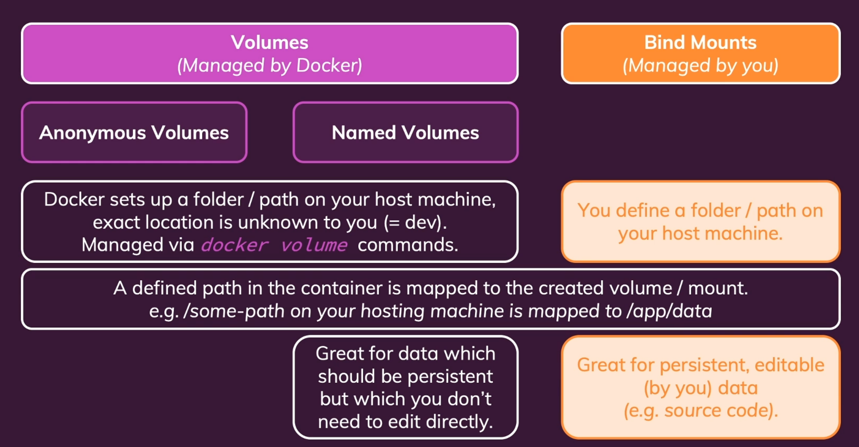

Note: We need to setup the Bind Mount from the Terminal when running the container.



-v for creating a bind mount

docker run -d -p 3000:80 --rm ---name my_app ***-v <path_to_the_host_folder>:<path_within_container>*** my_app:latest

Make Sure that Docker has access to the folder on the host.

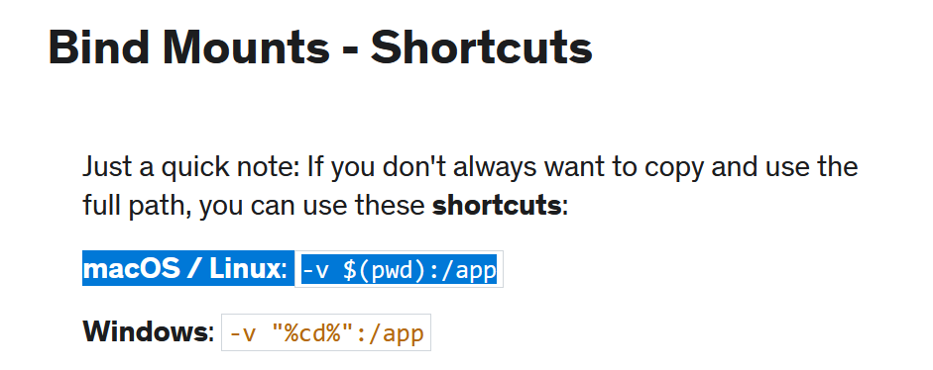

**Read-Only Volumes in Docker**

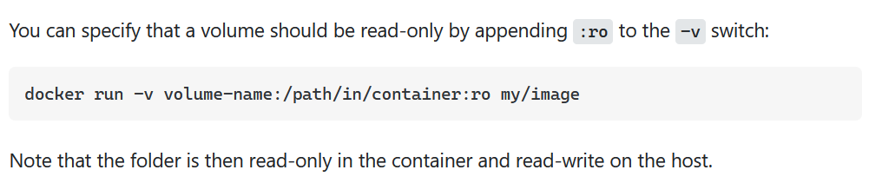

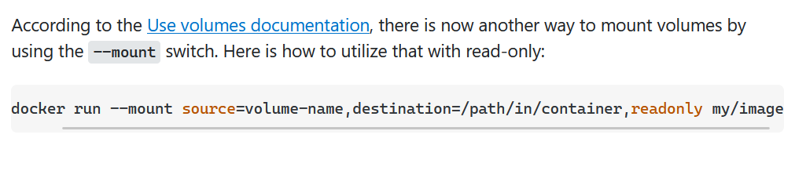

**Note:** Bind Mount are mostly used only in development but not in production

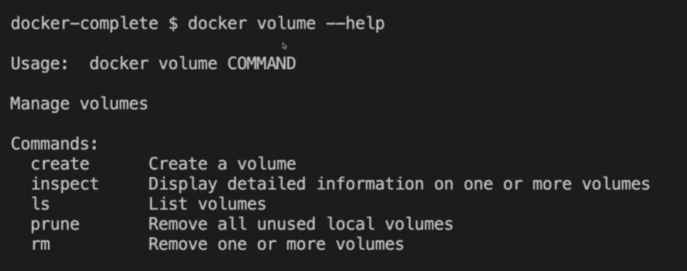

What is a Dockerignore file?

A: dockerignore is **a configuration file that describes files and directories that you want to exclude when building a Docker image.**

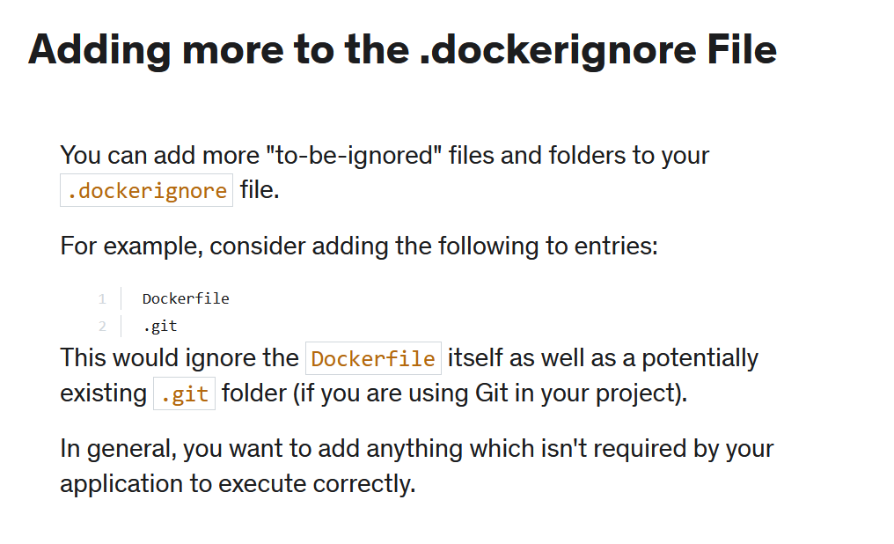



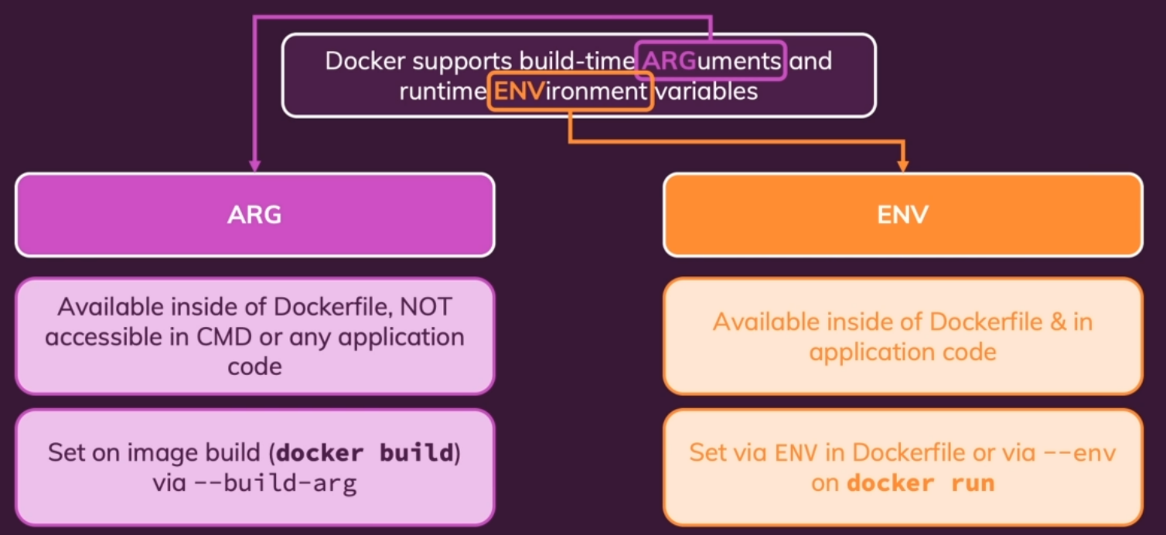

**Example:**

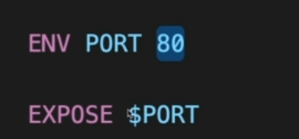

We can also create a file by name **.env** and use **--env-file** in the docker run command to give path to that file.

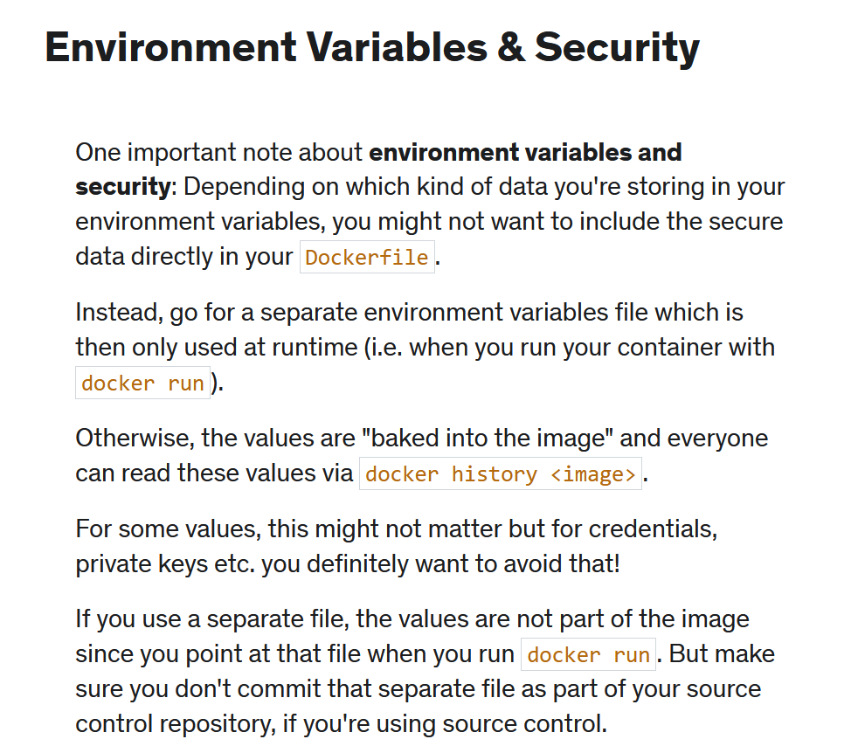

Example of **ARG**uments

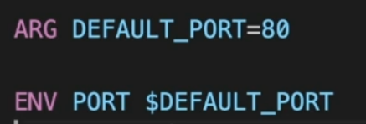

Example of passing the **ARG** at docker build command.

